Bash Scripting-02

Note: If the conditions/ifelse statements doesn’t match then, the error message should throw up. If correct, then the right ones should pop up when script is executed.

- Conditions/ifelse Statements:
Example 1 script is run below for ifelse count is 100;
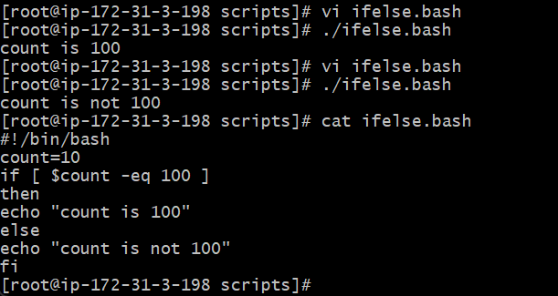

Example 2: Script is run for “File exist” / “File does not exist”

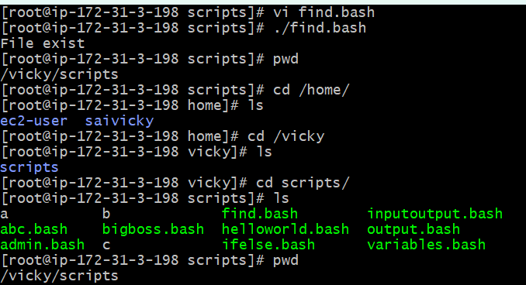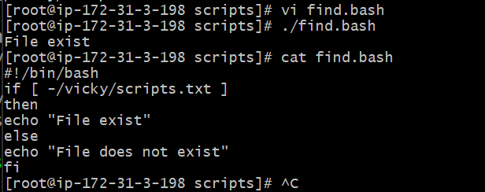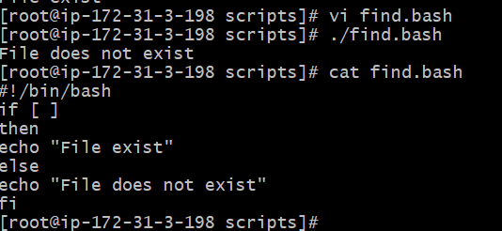

Exit Status Scripts
Every time a command is executed in Linux it will have status associated with it.
$?

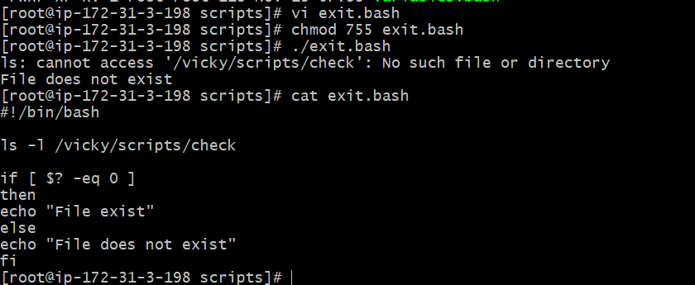
Once File name changed to “pwd”, then script executed to “File exist”
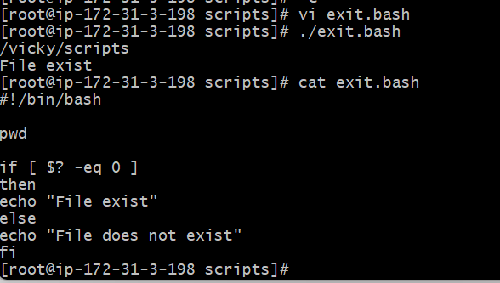

Bash Script Tasks
- Create a bash script to check if a directory is available or not.
To check if a directory is available or not, we have to follow a process and listed below.
- Create a directory- Mkdir dir1 dir2 dir3
- Then edit the script using new file- vi check-directory.bash
- In this script, I have used $dir as my variable
- Then provide permission to the file
- Then execute the script
- Once script executed, then verify if the directory is working or not by entering dir1, dir2 and dir3.
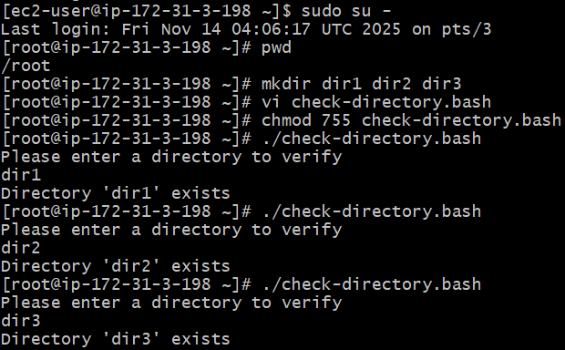
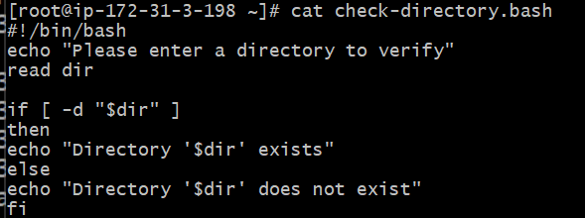
- Create a bash script to create multiple files.
- Created file as “Multiple-files.bash”
- Edited the script using vi to create multiple files
- Using Forloop scripts, used do - touch “file_$i.txt” to read ‘n’
- In for – ((i=1; i<=10; i++)) if i=1 or i<=10 or i++10, the number of files will be created when executing.
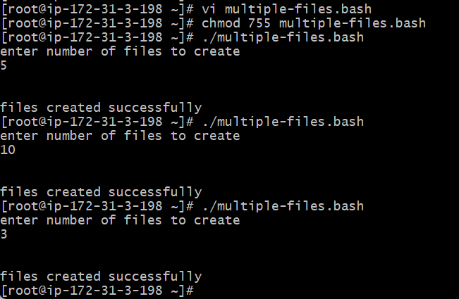
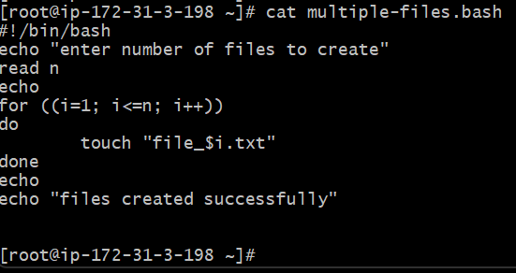
- Create a bash script to take a backup of a directory.
Step 1: Using LS I identified the existing Directory- Vicky_file
Step 2: Created vi file – vi backup_dir.bash
Step 3: Edited the script to create a backup directory for existing Vicky_file
Step 4: Created new directory as “Vicky_file_backup”
Step 5: Variable is $Dir Vicky_file_backup
Step 6: Condition for if -d “Vicky_file_backup/$dir
Step 7: I want the output as “Vicky file Directory in Vicky_file_backup”
Step 8: Success
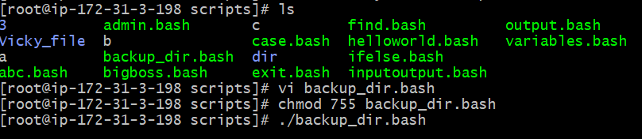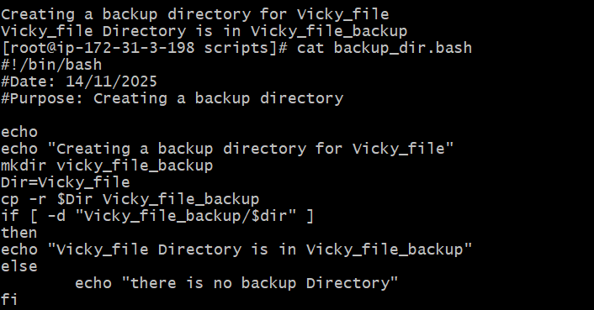
- Create a bash script to install Nginx on an EC2 server.
Steps-----
Step 1: Opened Gitbash to install Nginx and started the service from ec2
Step 2: Using Vi – edited the installation commands for Nginx and added purpose and comments on top of every command.
Step 3: Ran the script and found the script is active and running successfully.
Step 4: Verified in browser if the port number is working with 80.
Step 5: Successfully the Nginx is working.
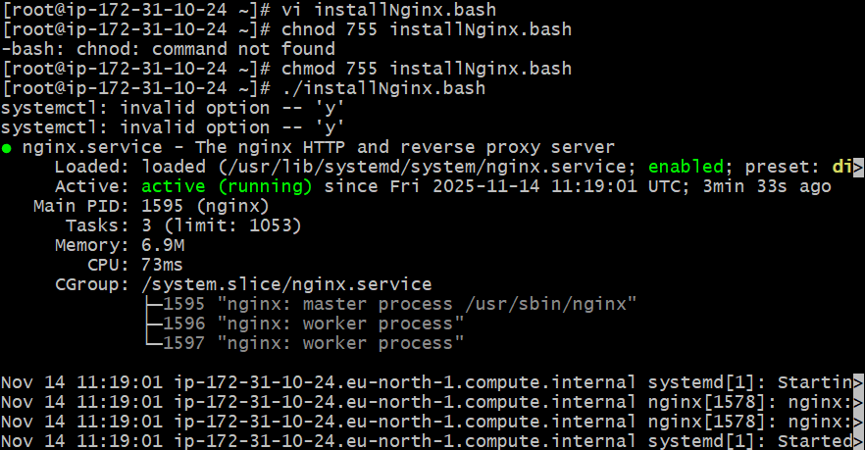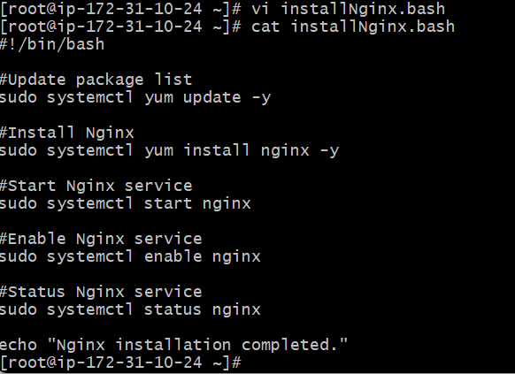
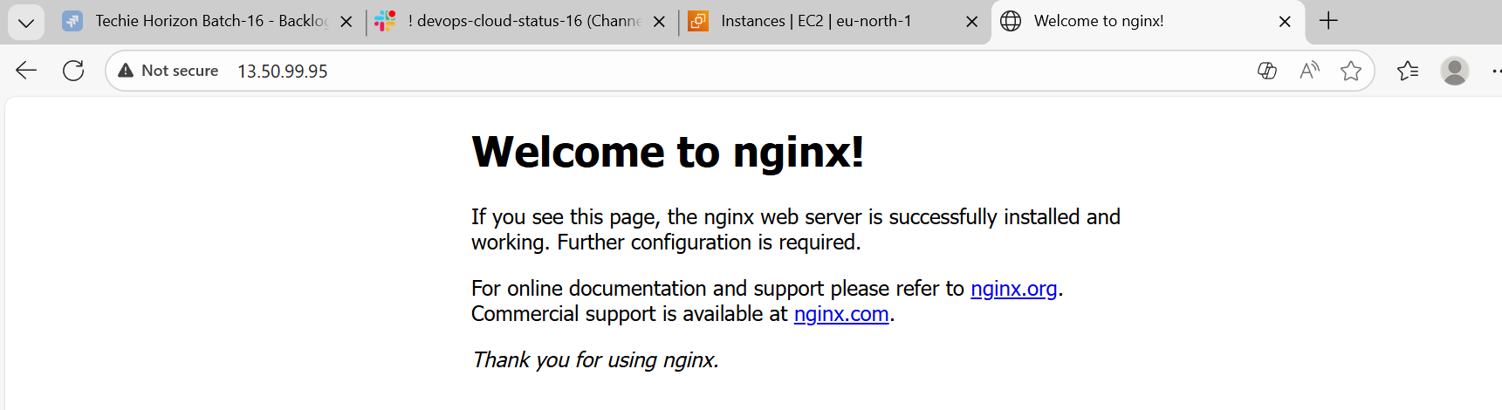
- Create a bash script to install Apache Tomcat on an EC2 server.
Steps
Step 1: Created script called install-apachetomcat.bash
Step 2: In my ec2 instance, already java is installed, so I skipped installing java in my script…
Step 3: Using wget installed apache tomcat
Step 4: Extract Tom cat and execute the command.
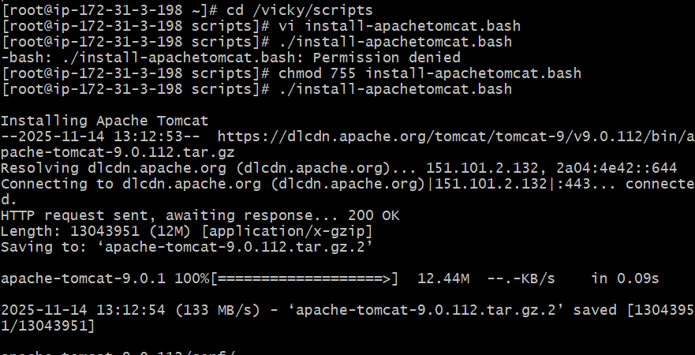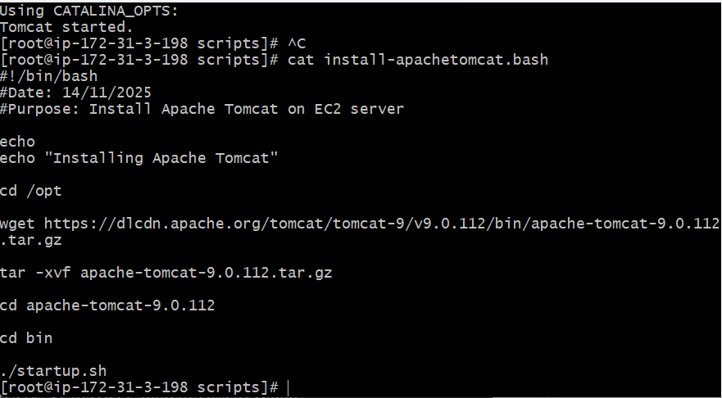

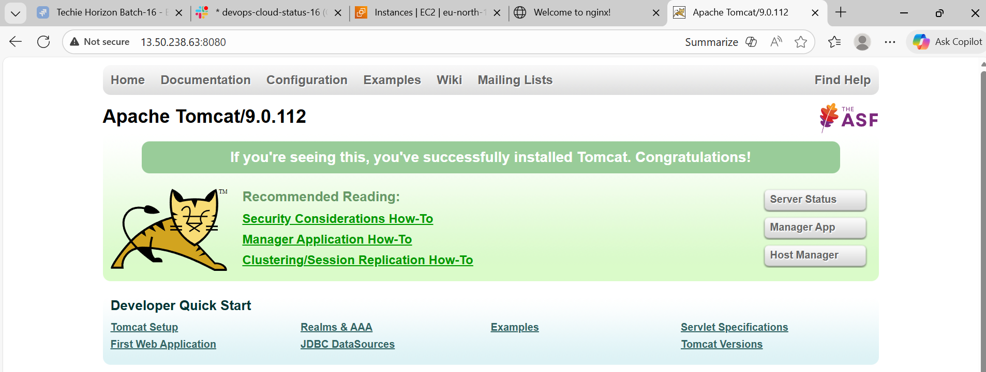

- Create a bash script to check if the Nginx service is running, if not running then script should start the service.
Steps
Step 1: Created vi startnginx.bash
Step 2: First we need to verify if nginx is active, if not then else command through nginx should start with command- “systemctl start nginx”
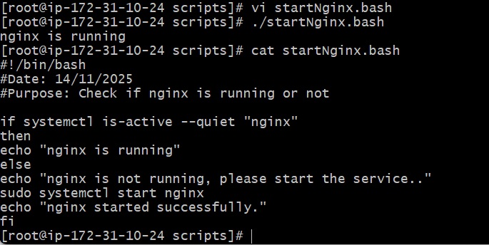

- Create a bash script for a calculator.
Steps
Step 1: Used command vi calculator.bash for editing script for the calculator
Step 2: I wanted to read 2 numbers and choose and operation either (add/subtract/multiply, divide) or give an error when chosen option as *
Step 3: Provided permission for the script and executed the script
Step 4: Success, the script worked and provided evidence below.
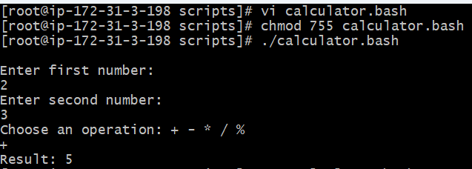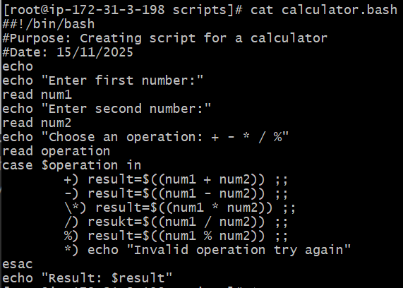

- Create a bash script to check if a directory exists, if not then create a directory.
Steps
Step 1: Created a script using vi command
Step 2: In this script, I didn’t ask for echo “Please verify if Directory exists or not”, instead, I used ‘if’ condition to verify if Directory exists, ‘else’ create a Directory.
Step 3: Success, Directory wasn’t available, so script created a Directory.
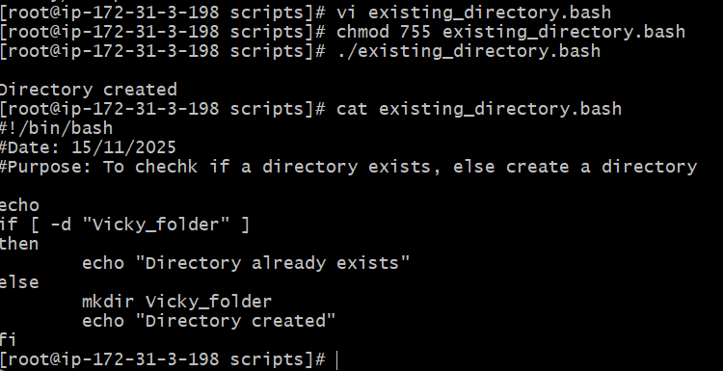

- Create a bash script to delete the last 3 lines of a file.
- Steps
- Step 1: Created a file to edit 5 lines minimum
- Step 2: Once created, edited a script to delete last 3 lines.
- Step 3: In the script, I used if condition for the file created King, where already I created the file for King, so the file exists.
- Step 4: As the file exists, I used sed command to delete the lines. Sed -I ‘$d’ “file.txt”
- Step 5: echo “deleted last 3 lines” – Success.

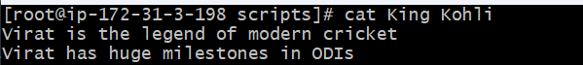
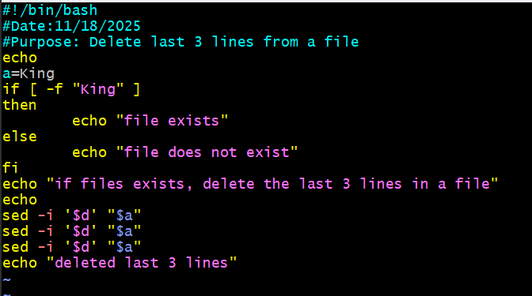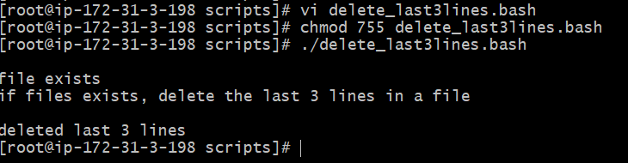
- Bash script to monitor cpu and if it is more than 80% then send email notification.
Steps
Step 1: Install yum install mailx for email alerts.
Step 2: Create a file to monitor cpu and if its more than 80%, send email notification.
Step 3: Our purpose was to verify 2 things in the script, 1 to check current CPU usage and 2 is to check threshold >80% then send email notification.
Step 4: We used ifelse condition if the current CPU usage is greater than Threshold 80. Success- Using Top command, we verified the CPU usage is not greater than 80.
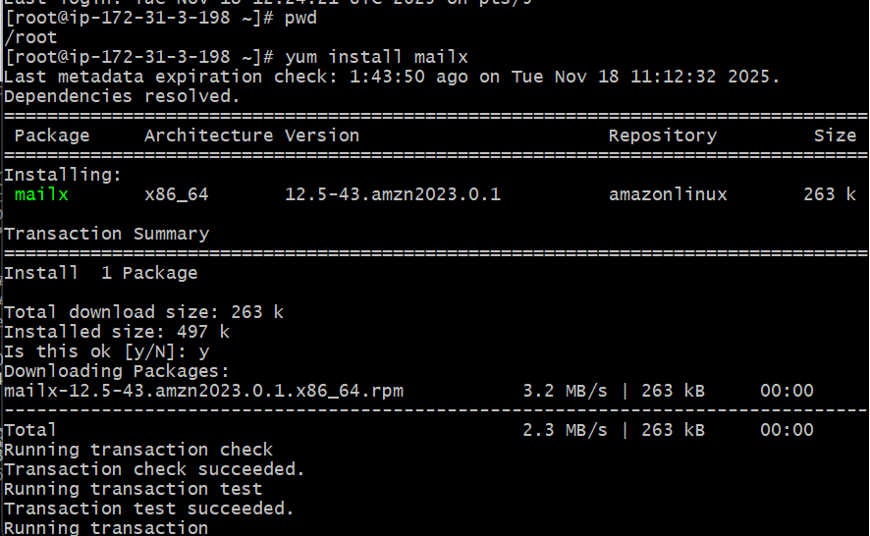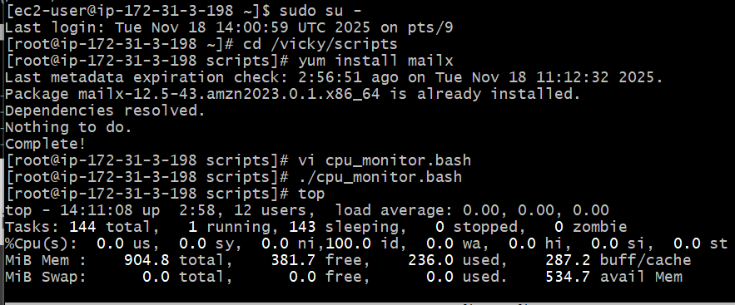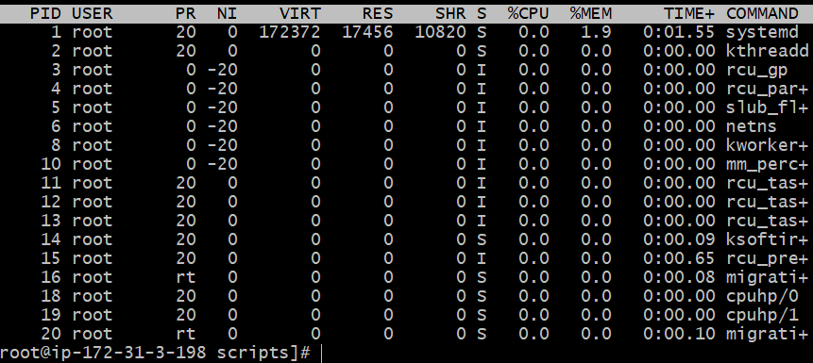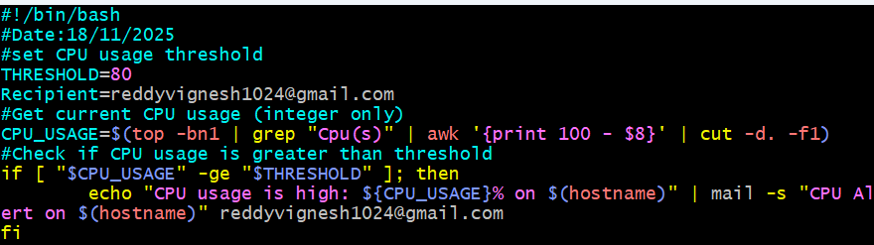
- Bash script to monitor disk space and if it is more than 80% then send email notification.
Steps
Step 1: Created script to monitor disk space and if it is more than 80%, send email notification is scripted.
Step 2: We used ifelse condition to verify if diskspace is greater than 80 or if it is less than 80, then send email notification in a format as below.
Subject- Disk space alert and usage alert
Body- File system alert on Usage.

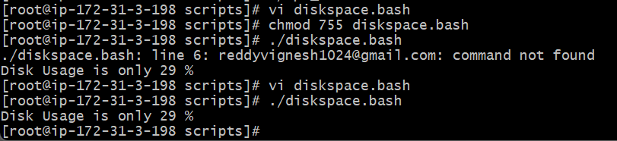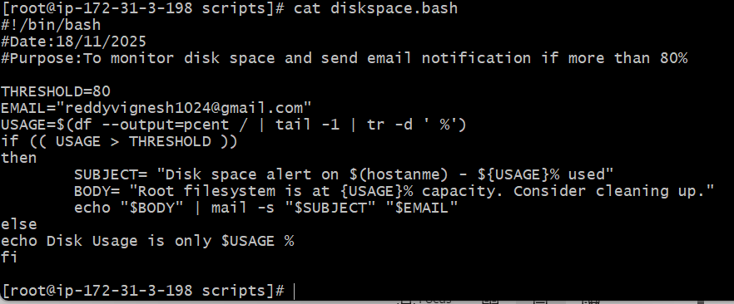
- Bash script to monitor memory and if it is more than 80% then send email notification.
Steps
Step 1: Used ifelse condition to verify if memory space is below 80% if else send email notification to recipient.
Step 2: Variable is $MEM_USAGE and $THRESHOLD
Step 3: Used awk command to take column 3, divide by 2 to do the calculations from 100.
Step 4: The memory is 28.3%. Success.
